IDEATION PHASE

PROBLEM STATEMENTS

|  |  |
| --- | --- |
| Date | 9 September 2022 |
| Team ID | PNT2022TMID33581 |
| Project Name | AI-POWERED NUTRITION ANALYZER  FOR FITNESS ENTHUSIASTS |

PROBLEM STATEMENT -1 :

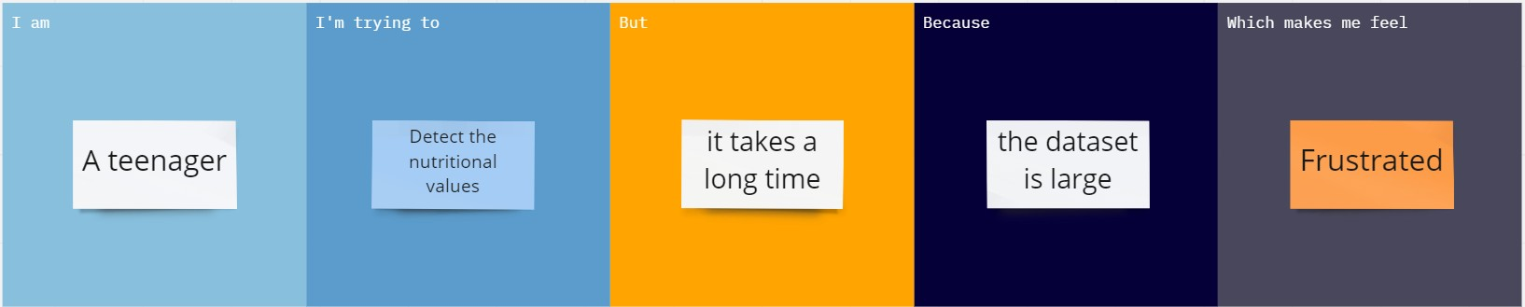

PROBLEM STATEMENT -2 :

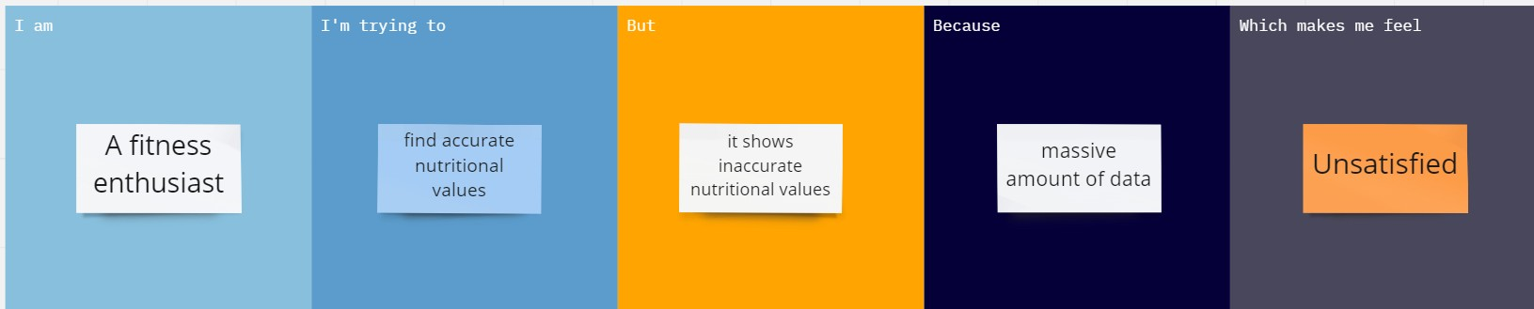

PROBLEM STATEMENT -3:

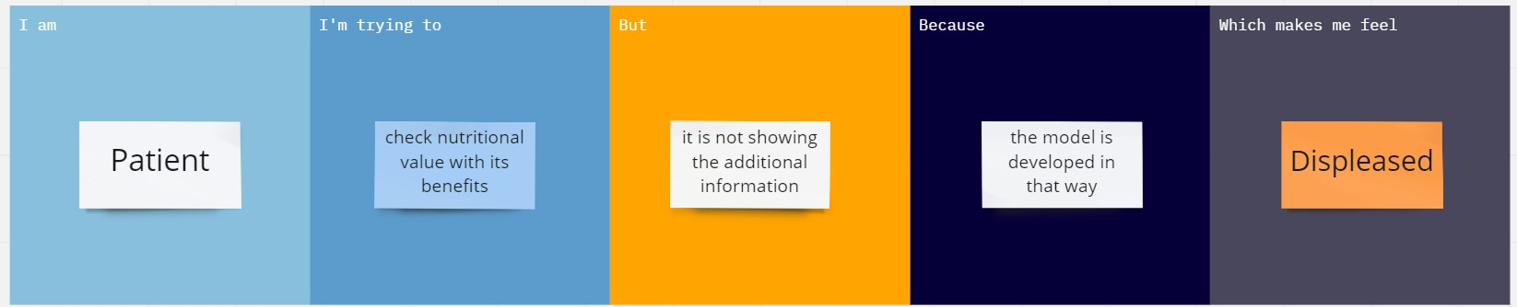

PROBLEM STATEMENT -4 :

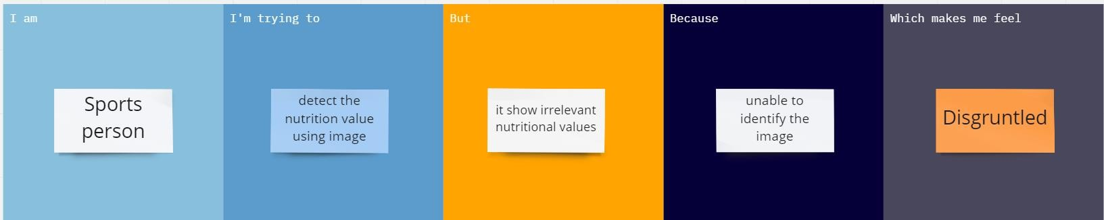

|  |  |  |  |  |  |
| --- | --- | --- | --- | --- | --- |
| Problem statement | I am | I*’*m trying to | But | Because | Which makes me feel |
| PS-1 | A teenager | Detect the nutritional values | It takes a long time | Large dataset | Frustrated |
| PS-2 | A fitness enthusiast | Find accurate nutritional values | It shows inaccurate nutritional values | Massive data | Unsatisfied |
| PS-3 | Patient | Check nutritional value with its benefits | It is not showing the additional information | The model is developed in that way | Displeased |
| PS-4 | Sports person | Detect the nutritional value using image | It shows irrelevant nutritional values | Unable to identify the image | Disgruntled |